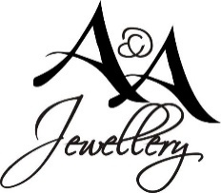
Donation Request Form

We are pleased to support those individuals and organizations who have supported A & A Jewellery.
All donation requests must be made using the form below and must be submitted a minimum of three weeks prior to the event.
Please be aware we are asked for at least 2 donations per week and have limited resources. If we are able to contribute to your event or organization, someone will contact you with further details.
A & A Jewellery does not give cash donations.

Name of Organization: _____________________________________________________
Please describe your organization: __________________________________________________________
______________________________________________________________________________________
Name of Event: _________________________________________________________________________
Date of Event: __________________________________________________________________________
Donation Required by (date): ______________________________________________________________
Non-Profit Status: Yes _______ No _______ Registered Number (If applicable) _____________________
How will the funds raised be used? _________________________________________________________
What type of donation are you looking for from A & A Jewellery? (Silent Auction, Door Price, Raffle, etc.) ______________________________________________________________________________________
How will A & A Jewellery be promoted? _____________________________________________________
______________________________________________________________________________________
Have you done business with A & A Jewellery in the past? _______________________________________
Why did your organization select A & A Jewellery for a donation? _________________________________
______________________________________________________________________________________

Contact Name (First and Last): _____________________________________________________________
Phone Number: _________________________________________________________________________
Email: _________________________________________________________________________________
Date: ______________________________
Office Use:
Yes_____ Contacted? ____ No _____
Item___________________
Value __________________

Please email to aandajewellery@sasktel.net or drop off in store.

